ACTIVE DIRECTORY EXPLOITATION
Laboratory Setup
By Maksym Salyha

In this file you can find the evidence of the project and troubleshooting process.

Evidence of the Lab
- Installation of windows server 2022
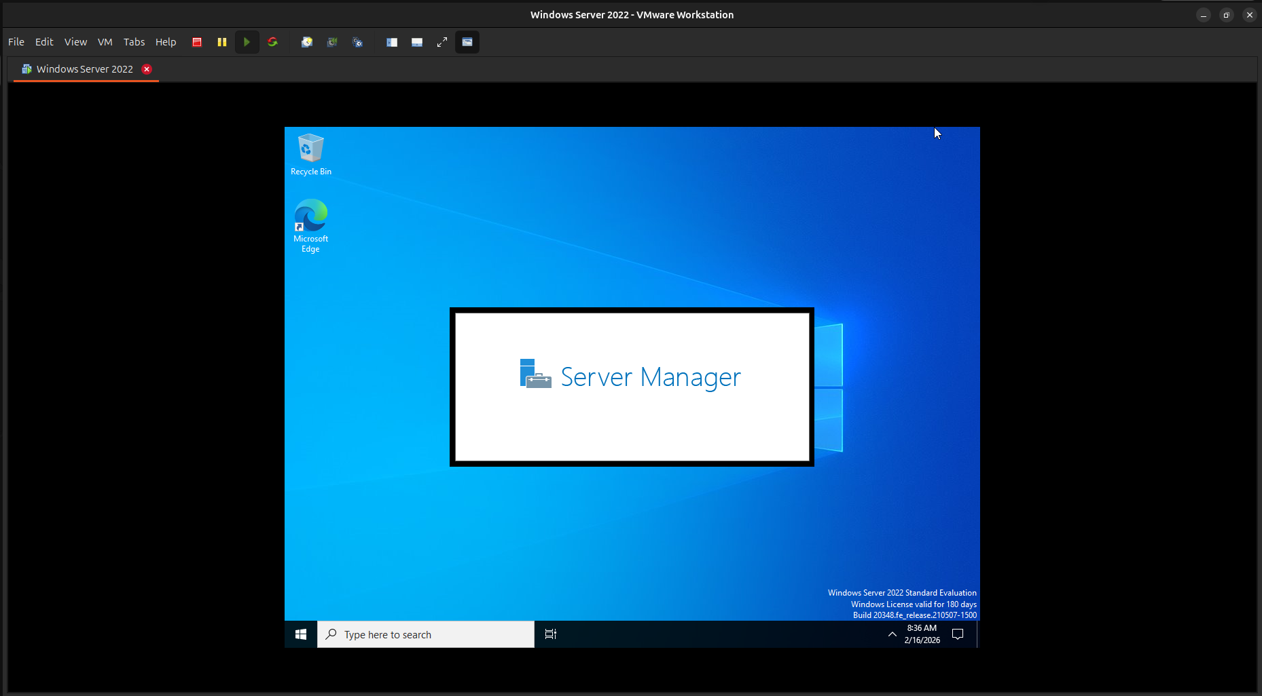

- Windows 10 ( User ) and Windows server 2022
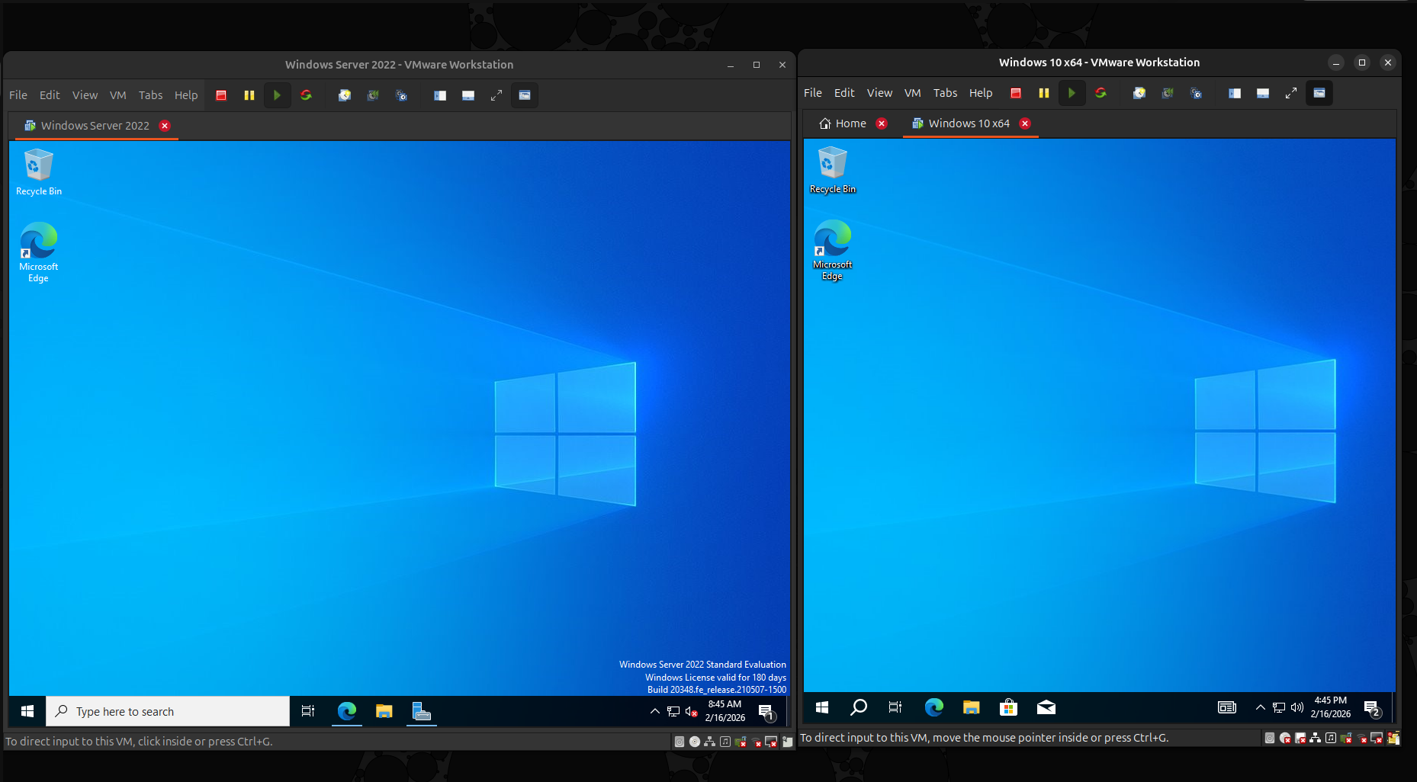

- Getting an IP address of windows server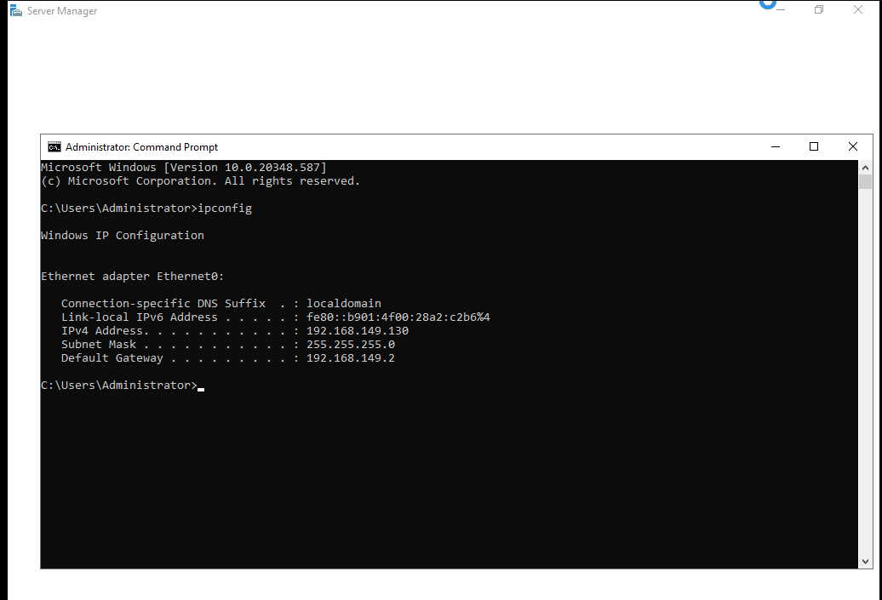

- Adding Roles and Features
- Creating Active Directory Domain Service
- Configuration of Domain Service
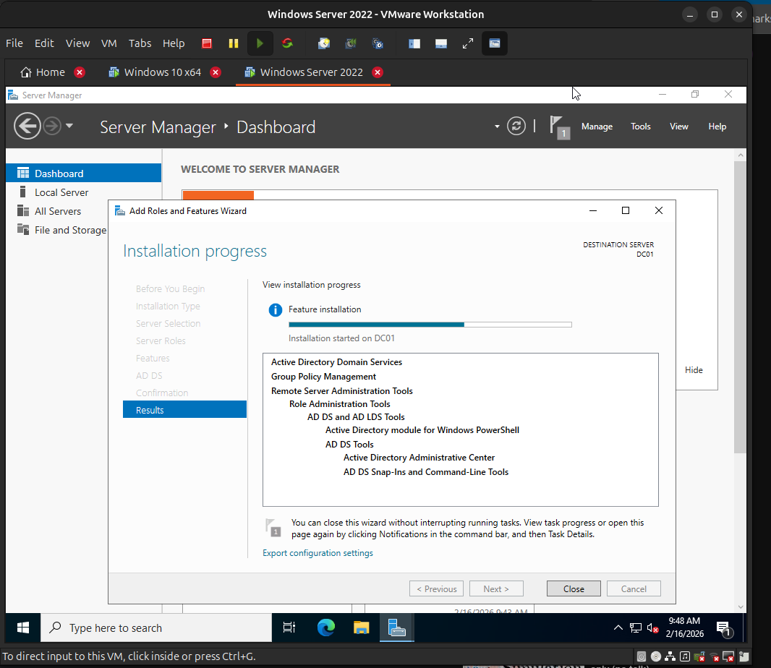

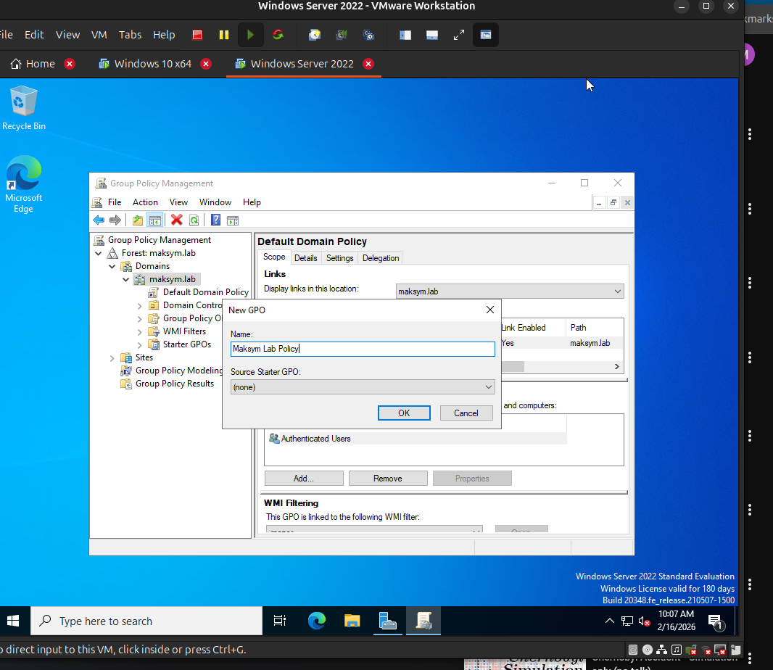
- Creating a Policy and updating the system to apply it
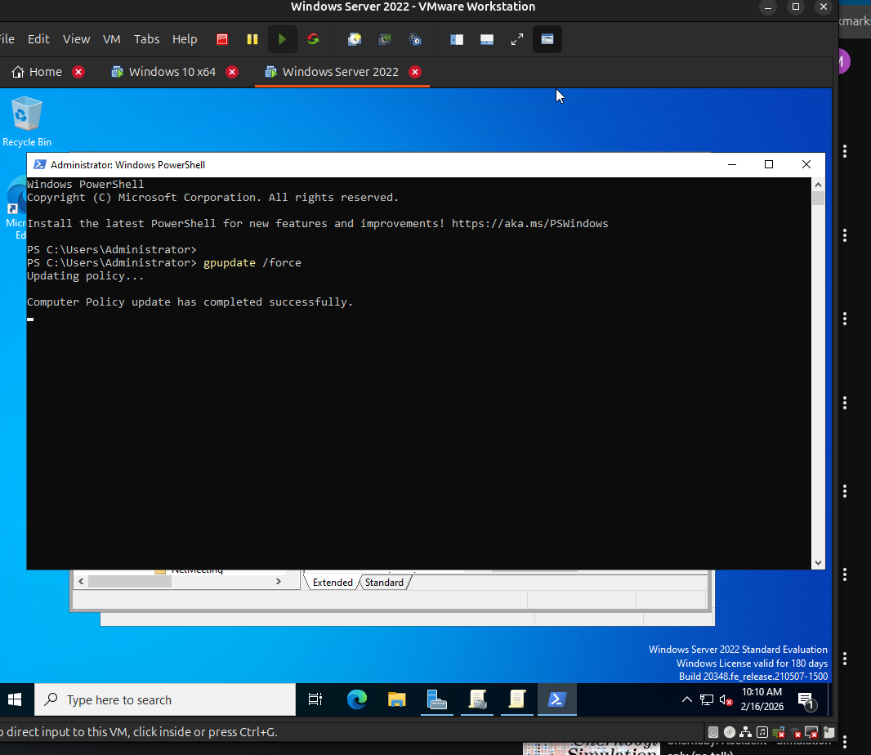

- The result of applying policies which disable auto update and Antivirus.
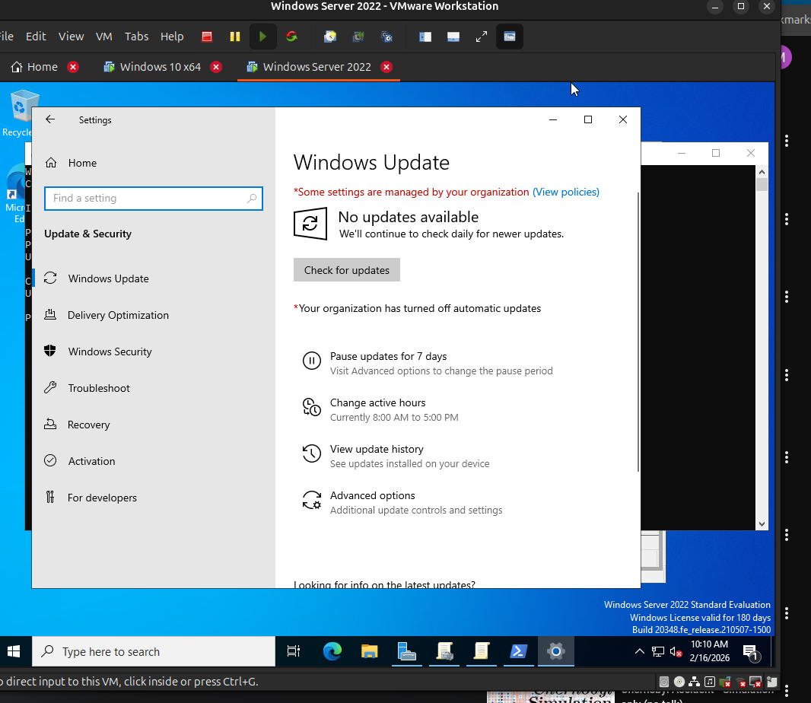
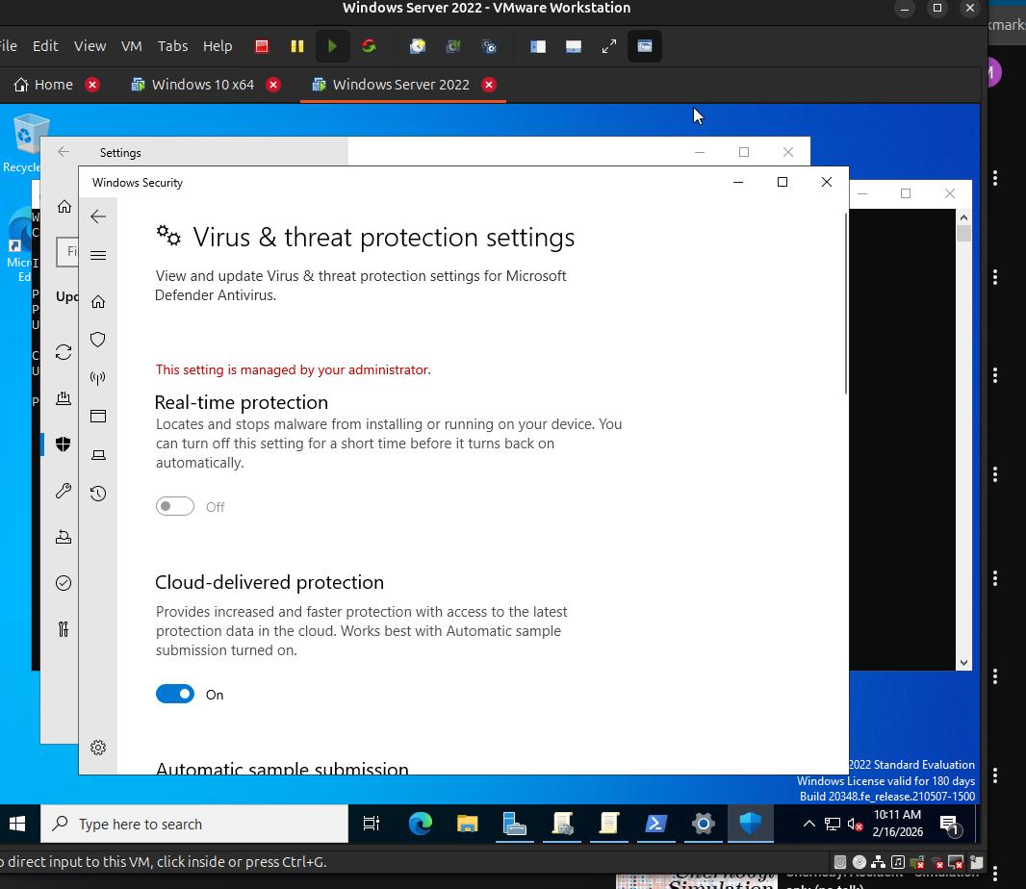

- Creating a user, encountered a problem with password policies. Solved in the Troubleshooting section.
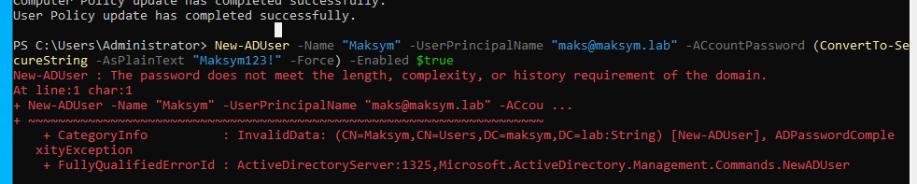
- The result:
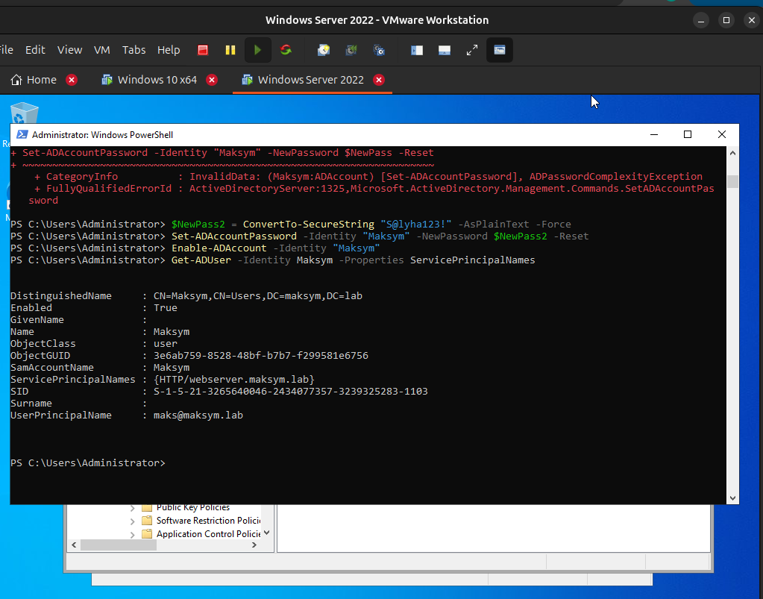

- Connecting user to Active Directory domain

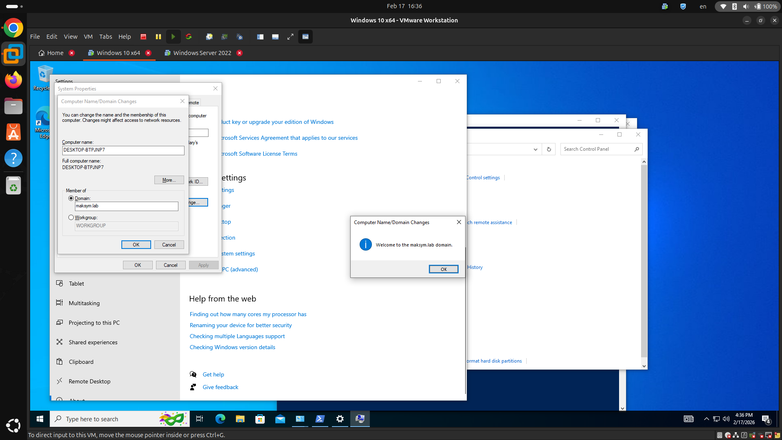

- Checking the new user in Active directory

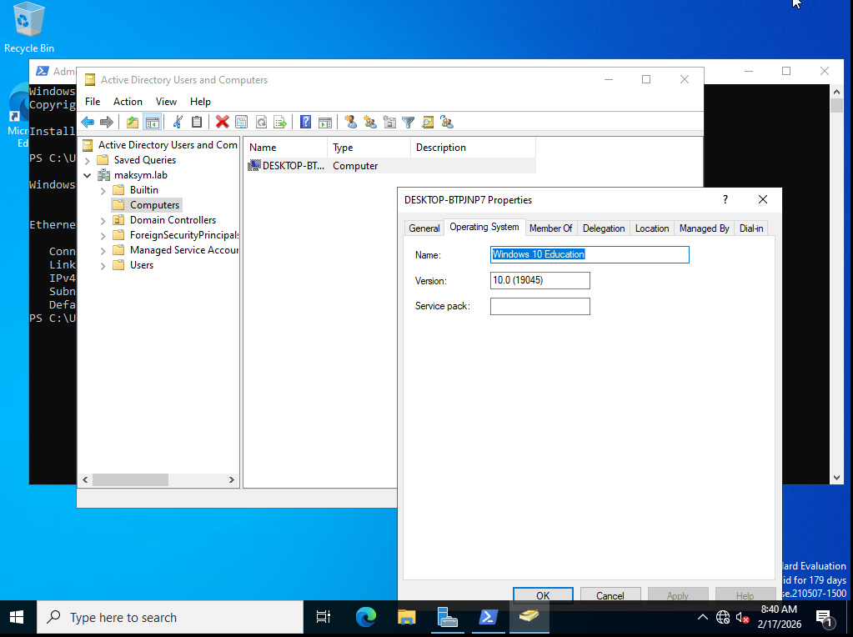

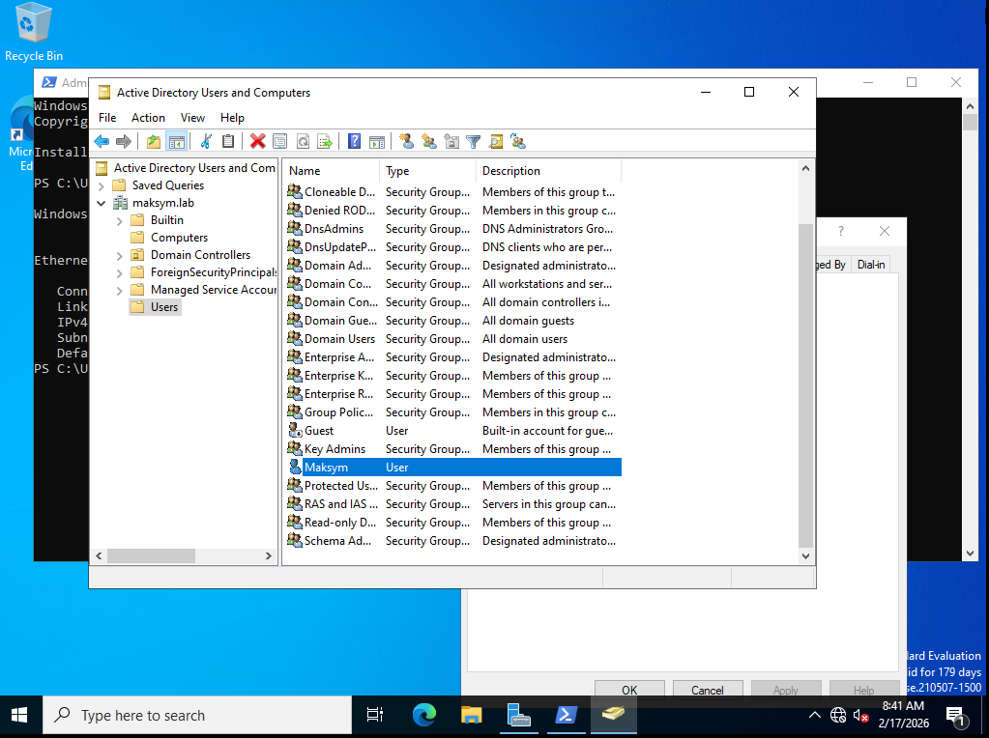

Troubleshooting

First problem occurred during creation of the winserver2022.
Error says following:
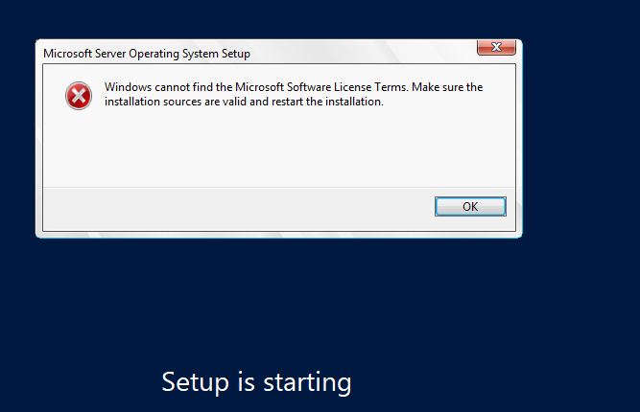

- The step to resolve the issue was to remove the floppy disk drive and restart the virtual machine.
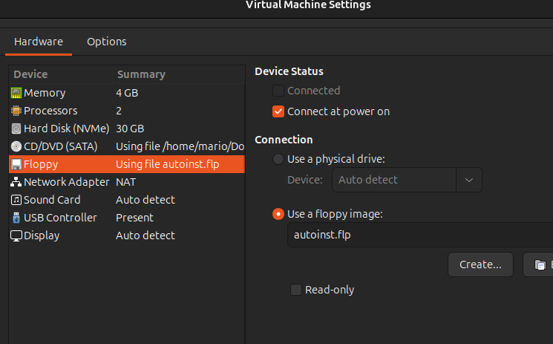

- The result:
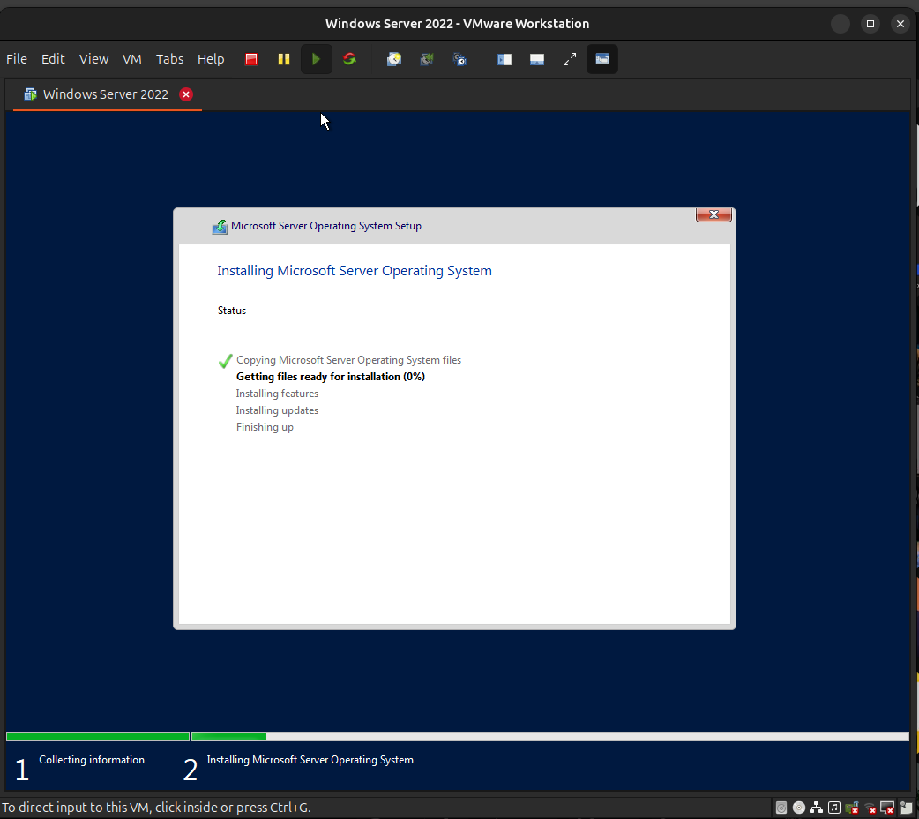

The second problem occurred during creating a user with a weak password.



- After changing password policies the problem didn’t disappear.

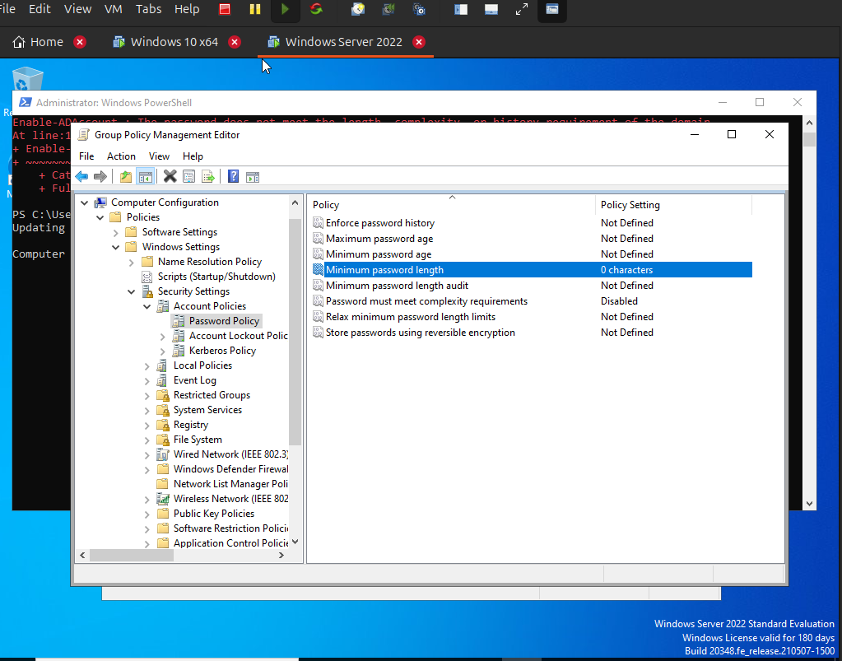

- The problem was solved when a new password was created that did not contain any mention of the user.

